实验8 文件管理

实验目的
- 理解内存页面调度的机理。
- 掌握几种理论页面值换算法的实现方法
- 通过实验比较各种调度算法的优劣。

实验内容
给出一个磁盘块序列：1、2、3、……、500，初始状态所有块为空的，每块的大小为2k。选择使用位表、链式空闲区、索引和空闲块列表四种算法之一来管理空闲块。对于基于块的索引分配执行以下步骤：
- 随机生成2k-10k的文件50个，文件名为1.txt、2.txt、……、50.txt，按照上述算法存储到模拟磁盘中。
- 删除奇数.txt（1.txt、3.txt、……、49.txt）文件
- 新创建5个文件（A.txt、B.txt、C.txt、D.txt、E.txt），大小为：7k、5k、2k、9k、3.5k，按照与（1）相同的算法存储到模拟磁盘中。
- 给出文件A.txt、B.txt、C.txt、D.txt、E.txt的文件分配表和空闲区块的状态。）

实验环境
ubuntu-22.04.5

实验中遇到的主要问题及其解决方式
在释放资源时代码运行错误，在Windows系统下对代码进行debug后修改代码。虚拟机上ceil函数会报错，采用自定义函数自行计算。

源代码
#include<stdio.h>
#include<stdlib.h>
#include<string.h>
#include<time.h>
#include<math.h>//????why no ceil
#define DISK_BLOCKS 500
#define BLOCK_SIZE 2
#define MAX_FILES 55

typedef struct DiskBlock
{
int block_id;
int file_id;
struct DiskBlock* next;
}DiskBlock;
typedef struct File
{
int file_id;
char name[20];
double size_kb;
int blocks_needed;
DiskBlock* first_block;
struct File* next;
}File;
DiskBlock* free_list =NULL;
File* file_list=NULL;
int total_free_blocks=DISK_BLOCKS;
void initialize_disk()
{
printf("total disk blocks: %d, per block size: %dKB\n",DISK_BLOCKS,BLOCK_SIZE);
for(int i=DISK_BLOCKS;i>=1;i--)
{
DiskBlock* new_block=(DiskBlock*)malloc(sizeof(DiskBlock));
new_block->block_id=i;
new_block->file_id=0;
new_block->next=free_list;
free_list=new_block;
}
total_free_blocks=DISK_BLOCKS;
printf("free blocks: %d",total_free_blocks);
}
void display_free_list()
{
printf("\ncurrent free blocks list: ");
DiskBlock* current=free_list;
int count=0;
while(current!=NULL&&count<20)
{
printf("%d ",current->block_id);
current=current->next;
count++;
}
if(current!=NULL)
{
printf("\ttotal blocks: %d\n",total_free_blocks);
}
else
{
printf("\n");
}
}
int calculate_blocks_needed(double size_kb)
{
const int PRECISION=1000;
long long size_int=(long long)(size_kb*PRECISION);
long long block_int=(long long)(BLOCK_SIZE*PRECISION);
return (int)((size_int+block_int-1)/block_int);
}
DiskBlock* allocate_blocks(int blocks_needed)
{
if(blocks_needed>total_free_blocks)
{
printf("free blocks is not enough.");
return NULL;
}
DiskBlock* allocated_chain=NULL;
DiskBlock* last_allocated=NULL;
DiskBlock* rollback_chain=NULL;
for(int i=0;i<blocks_needed;i++)
{
if(free_list==NULL)
{
printf("Error: free blocks list is NULL");
DiskBlock* rb_current=rollback_chain;
DiskBlock* rb_last=NULL;
while(rb_current!=NULL)
{
rb_current->file_id=0;
rb_last=rb_current;
rb_current=rb_current->next;
}
if(rb_last!=NULL)
{
rb_last->next=free_list;
free_list=rollback_chain;
}
total_free_blocks+=i;
return NULL;
}
DiskBlock* allocated_block=free_list;
free_list=free_list->next;
total_free_blocks--;
allocated_block->next=NULL;
if(allocated_chain==NULL)
{
allocated_chain=allocated_block;
last_allocated=allocated_block;
}
else
{
last_allocated->next=allocated_block;
last_allocated=allocated_block;
}
if(rollback_chain==NULL)
{
rollback_chain=allocated_block;
}
}
return allocated_chain;
}
File* create_file(int file_id,const char* name,double size_kb)
{
int blocks_needed=calculate_blocks_needed(size_kb);
if(blocks_needed>total_free_blocks)
{
printf("Error: can't create file %s, free blocks is not enough\n",name);
return NULL;
}
DiskBlock* allocated_blocks=allocate_blocks(blocks_needed);
if(allocated_blocks==NULL)
{
return NULL;
}
File* new_file=(File*)malloc(sizeof(File));
new_file->file_id=file_id;
strncpy(new_file->name,name,sizeof(new_file->name)-1);
new_file->name[sizeof(new_file->name)-1]='\0';
new_file->size_kb=size_kb;
new_file->blocks_needed=blocks_needed;
new_file->first_block=allocated_blocks;
new_file->next=NULL;
DiskBlock* current_block=allocated_blocks;
while(current_block!=NULL)
{
current_block->file_id=file_id;
current_block=current_block->next;
}
if(file_list==NULL)
{
file_list=new_file;
}
else
{
File* current=file_list;
while(current->next!=NULL)
{
current=current->next;
}
current->next=new_file;
}
printf("create file: %s(size: %.1fKB, blocks num: %d)\n",name,size_kb,blocks_needed);
return new_file;
}
int blocks_in_chain(DiskBlock* block_chain)
{
int count=0;
DiskBlock* current=block_chain;
while(current!=NULL)
{
count++;
current=current->next;
}
return count;
}
void release_blocks(DiskBlock* block_chain)
{
if(block_chain==NULL)
{
return;
}
DiskBlock* current=block_chain;
DiskBlock* last=NULL;
while(current!=NULL)
{
current->file_id=0;
last=current;
current=current->next;
}
int blocks=blocks_in_chain(block_chain);
if(last!=NULL)
{
last->next=free_list;
free_list=block_chain;
total_free_blocks+=blocks;
}
}
void delete_file_by_name(const char* name)
{
File* prev=NULL;
File* current=file_list;
while(current!=NULL)
{
if(strcmp(current->name,name)==0)
{
release_blocks(current->first_block);
if(prev==NULL)
{
file_list=current->next;
}
else
{
prev->next=current->next;
}
printf("delete file: %s(release %d block)\n",name,current->blocks_needed);
free(current);
return;
}
prev=current;
current=current->next;
}
printf("Warning: can't find file %s\n",name);
}
void display_file_allocation(const char* name)
{
File* current=file_list;
while(current!=NULL)
{
if(strcmp(current->name,name)==0)
{
printf("\nfile %s allocation:\n",name);
printf("file size: %.1fKB\n blocks num:%d\n allocate block: ",current->size_kb,current->blocks_needed);
DiskBlock* block=current->first_block;
while(block!=NULL)
{
printf("%d",block->block_id);
if(block->next!=NULL)
{
printf(" -> ");
}
block=block->next;
}
printf("\n");
return;
}
current=current->next;
}
printf("can't find file %s\n",name);
}
int generate_random_size()
{
return (rand()%9)+2;
}
void create_random_files()
{
srand(time(NULL));
for(int i=1;i<=50;i++)
{
char filename[20];
sprintf(filename,"%d.txt",i);
int file_size=generate_random_size();
create_file(i,filename,file_size);
}
display_free_list();
}
void delete_odd_files()
{
for(int i=1;i<=50;i+=2)
{
char filename[20];
sprintf(filename,"%d.txt",i);
delete_file_by_name(filename);
}
display_free_list();
}
void create_new_files()
{
File* fileA=create_file(51,"A.txt",7);
File* fileB=create_file(52,"B.txt",5);
File* fileC=create_file(53,"C.txt",2);
File* fileD=create_file(54,"D.txt",9);
File* fileE=create_file(55,"E.txt",3.5);
display_free_list();
}
void display_all_files_allocation()
{
File* current=file_list;
int file_count=0;
while(current!=NULL)
{
display_file_allocation(current->name);
current=current->next;
file_count++;
}
printf("\ntotal file nums: %d",file_count);
}
void display_disk_block_status()
{
printf("total block nums: %d\nfree block nums: %d\nused block nums: %d\nfree rate: %.2f%%\n",DISK_BLOCKS,total_free_blocks,DISK_BLOCKS-total_free_blocks,(double)total_free_blocks/DISK_BLOCKS*100);
}
void cleanup()
{
File* file_current=file_list;
while(file_current!=NULL)
{
File* next_file=file_current->next;
DiskBlock* block_current=file_current->first_block;
while(block_current!=NULL)
{
DiskBlock* next_block=block_current->next;
free(block_current);
block_current=next_block;
}
free(file_current);
file_current=next_file;
}
DiskBlock* block_current=free_list;
while(block_current!=NULL)
{
DiskBlock* next_block=block_current->next;
free(block_current);
block_current=next_block;
}
free_list=NULL;
file_list=NULL;
total_free_blocks=0;
}
int main()
{
initialize_disk();
create_random_files();
delete_odd_files();
create_new_files();
display_file_allocation("A.txt");
display_file_allocation("B.txt");
display_file_allocation("C.txt");
display_file_allocation("D.txt");
display_file_allocation("E.txt");
//display_all_files_allocation();
display_disk_block_status();
cleanup();
return 0;
}

程序流程图
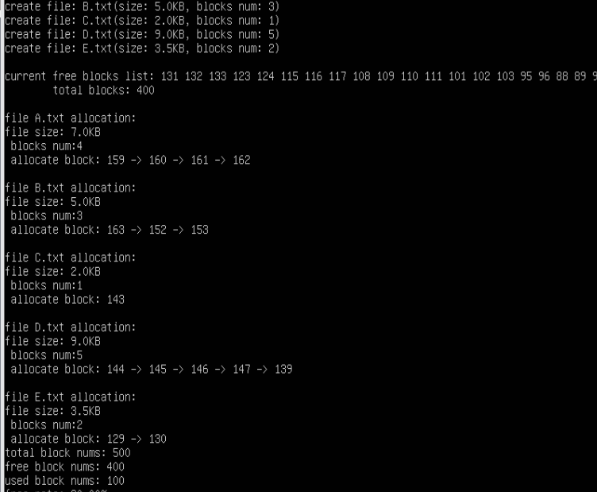
调试运行结果，未显示完全。
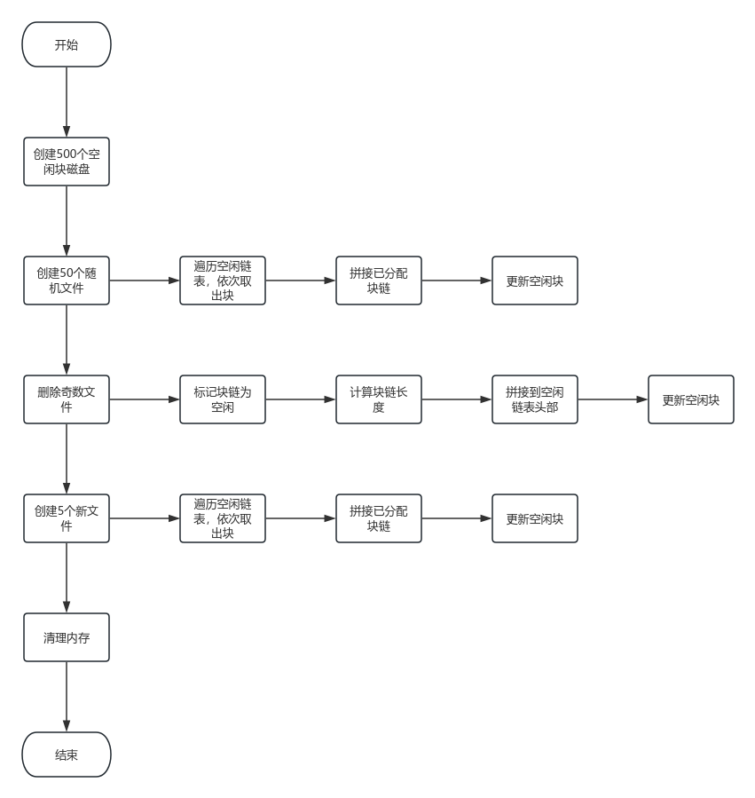

实验总结
本次实验采用空闲块列表算法模拟了磁盘对空闲块的管理，对文件系统的相关算法有了更深的理解，对C语言链表的使用更加熟练了。
空闲块列表算法实现简单，位表存储开销低，位运算速度快，链式空闲区能够有效减少外部碎片，索引分配支持随机访问。

